PeopleSoft Grading

- To enter grades in PeopleSoft, begin by logging in as usual [Faculty Center].
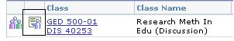
- You will see two images next to each class name – one for the class roster and the other for the grade roster.

- Click the Grade Roster image to begin entering grades.
- You will see a list of students with a “pull down menu” next to each name.
- Click on the menu (little box with an arrow) and choose the appropriate grade.
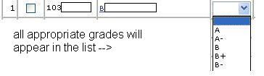


- If you are not entering all the grades at one time, you will want to click the SAVE button at the bottom of the screen.

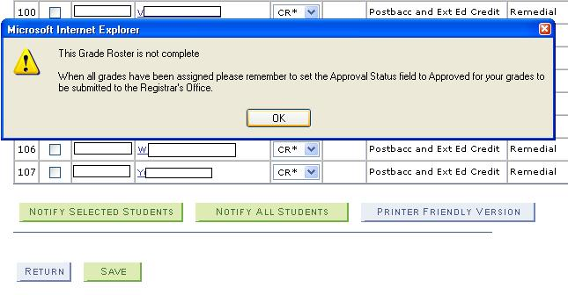
You will probably see a message reminding you that you will (later) need to review and confirm that the grades are correct before they are “rolled over” to the students’ records.

- If you have entered and reviewed all the grades, be sure to change the status (above the grade list) from Not Reviewed to Approved.

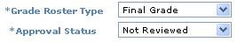

- Other features –

  - You can print out a spreadsheet version of the grade roster (or class roster) by clicking this symbol:
  - You can give all students the same grade by clicking the green box (unusual but possible!):

