Entering Incomplete Grade (I) “Contracts” in PeopleSoft

You will now be able (and required) to enter the information about Incomplete (I) grades without submitting the paper Incomplete Grade Request that we have used before.
NOTE: You will not be able to “approve” your grades (final step in grade submission) until you complete the steps below for all I grades on the roster (not RP or WU, just I).

- Login to PeopleSoft/MyCSUDH (Faculty Center) as you normally would to enter your grades.
- Click the “grade roster” image, just as you would usually do.
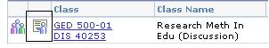

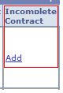
- As you enter grades, if you choose I from the list, you will see the word Add appear in a separate column called Incomplete Contract.

- When you click on the word Add, this screen will appear:
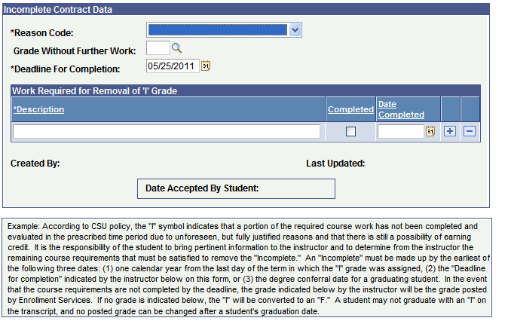
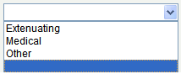

- Choose a reason from the drop-down list (Extenuating, Medical or Other) and enter a description of what is needed to complete the class. Use the sign to add more lines in the description.
- Use the default Deadline for Complete Date or change it – either way is fine. It will default to one year after the end of the current semester.
- You do not need to enter Grade Without Further Work. You can ignore Date Accepted by Student.
- Click OK or Apply to go back to entering or submitting grades.
- You will still need to file a Change of Grade Form when the student completes the missing work.

