Proyecto Arqueológico Tumbes: 2006 annual report.

Jerry D. Moore (California State University Dominguez Hills)

Annual Report to National Science Foundation—Submitted March 16, 2007

1) MAJOR RESEARCH ACTIVITIES
During the 2006 field season, the Proyecto Arqueológico Tumbes (PAT) conducted a program of excavation and analysis at two archaeological sites, Loma Saavedra and El Porvenir, located in the Rio Zarumilla drainage in the Department of Tumbes, Peru (Figure 1). The research was approved by the Instituto Nacional de Cultura by Resolución Directoral Nacional No. 783/INC, authorized on May 29, 2006. The research was funded by NSF Award 0549454.

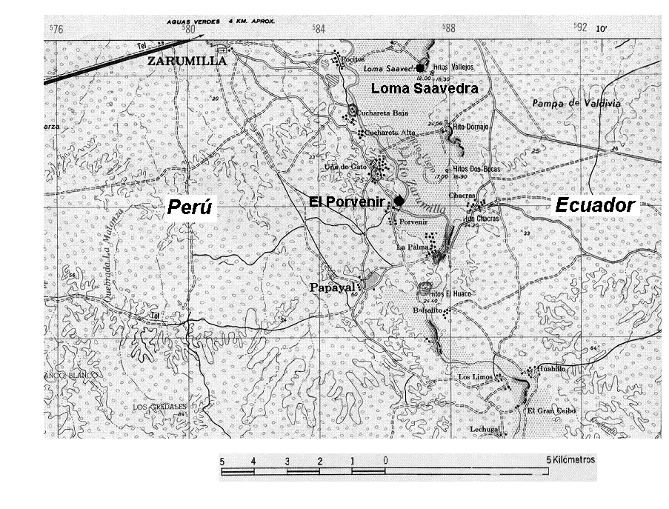

Figura 1. Locations of Archaeological Sites El Porvenir and Loma Saavedra, Zarumilla Province, Departament of Tumbes, Peru.

The 2006 fieldwork was one phase of a multi-year program of archaeological investigations focusing on the creation of architectural space and the development of different modes of socio-political power in the Department of Tumbes, one of the least studied regions in Andean South America. Beginning with an archaeological reconnaissance in 1996 (Moore et al 1996, 1997), followed by a modest 2003 testing program at Loma Saavedra (Moore and Vilchez 2005), the 2006 excavations focused on a comparative study of domestic architecture of two sites from different time periods. The 2007 fieldwork will focus on excavations in public architecture at two other sites, Santa Rosa and Uña de Gato. In addition to its focus on the creation of architectural spaces by prehispanic societies in far northern Peru, the research was designed to recover basic archaeological data regarding chronology, ceramic stylistic variation, prehistoric exploitation of faunal and floral resources, and exchange networks. As will be discussed below (see “Major Findings”), the results of the 2006 research were surprising and intriguing, leading to completely unanticipated evidence for the antiquity and variability of the archaeological record in the Department of Tumbes.

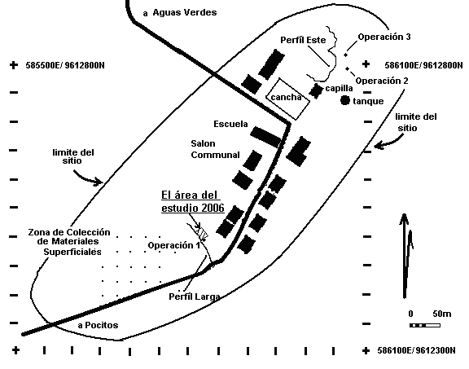

Figure 2: Loma Saavedra, Location of Excavations, Operación 1.

The site of Loma Saavedra (Ravines 1973; Moore et al 1996, Moore, Vilchez and Pajuelo 2003) is located near the hamlet of the same name in the District of Aguas Verdes, Zarumilla Province, Department of Tumbes on the lower valley on the western bank of the Rio Zarumilla (UTM 586054 E/9612753N). The site of Loma Saavedra is approximately 700 m (northwest-southeast) by 500 m at its widest point with a surface

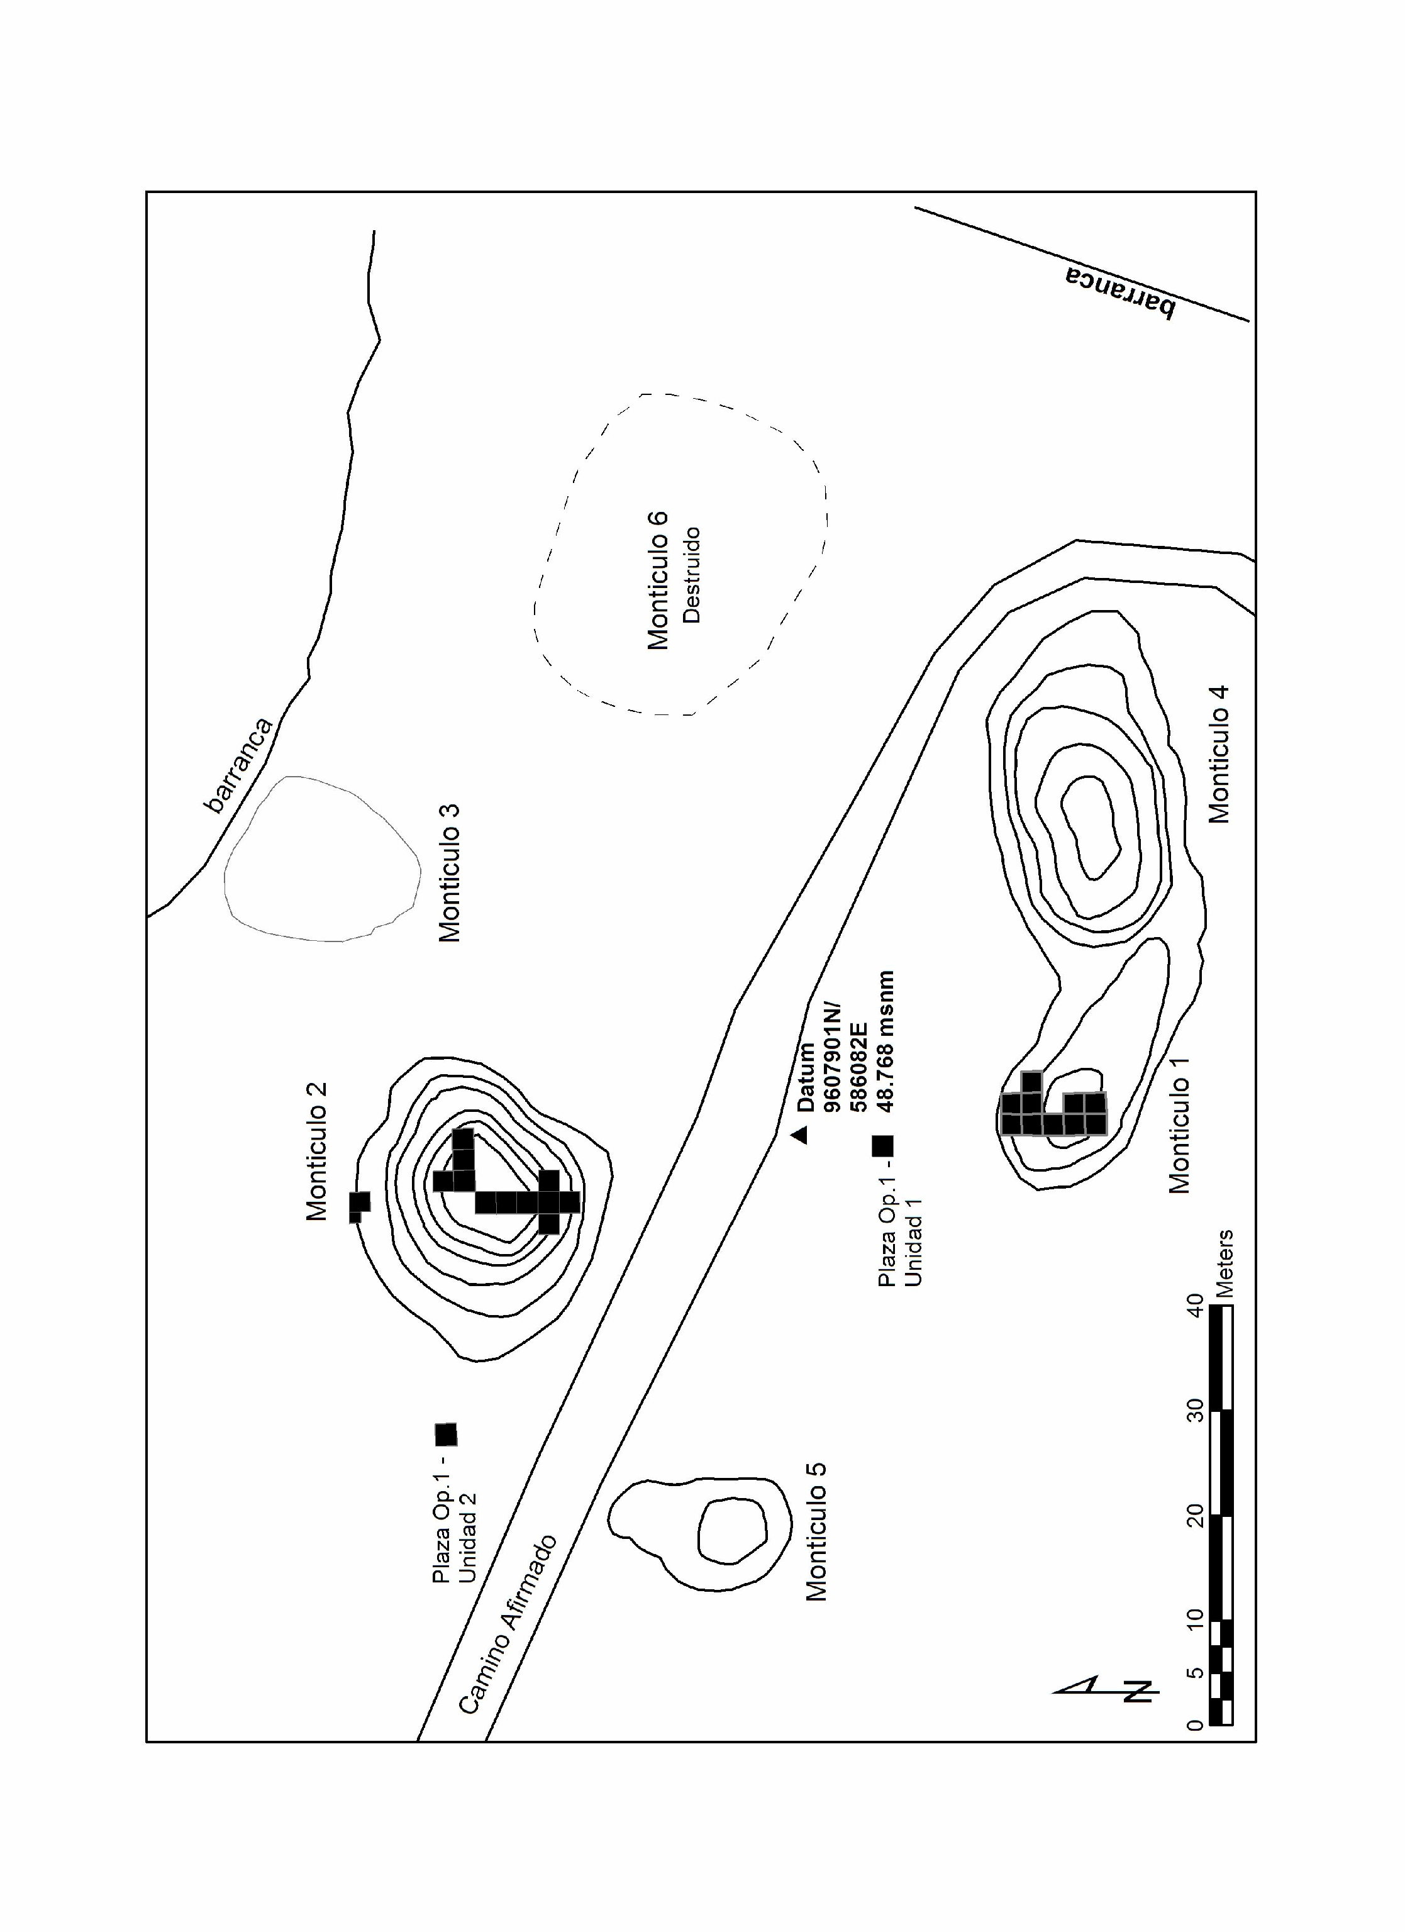
Figura 3: El Porvenir, Excavation Locations

area of 28 hectares (Figure 2). The site is located on a long knoll surrounded by seasonally inundated areas; in the 1998 El Nino/Southern Oscillation event, the community of Loma Saavedra was surrounded by flood waters for several months, according to local inhabitants. The site is stretched across this higher landform and consists of surface middens of ceramics and shell remains.
The site of El Porvenir is located in the Papayal District, Zarumilla Province, Department of Tumbes (UTM 586106E/9608005 N), near the community of same name (Moore et al 1997). The archaeological remains are located on a terrace on the southern bank of the Zarumilla River, covering an area of 300 m (east-west) by 100 m (north-south) and consisting of six artificial mounds surrounded by areas of shell middens (Figure 3).
Excavations were conducted between May 30 and July 27, 2006 at El Porvenir and Loma Saavedra. The excavations at El Porvenir focused on three areas: Mound I, Mound II, and the plaza (Plaza Operations 1 and 2). At Loma Saavedra the excavations expanded on Operation 1, an area in the southern portion of the site where testing in 2003 encountered sets of postmolds
Essentially, the same methods were used in both sites. Horizontal excavations were laid out in 2m X 2m units and excavated in natural and cultural levels using hand tools. In addition to the block excavations, a limited number of test pits were placed to test plaza areas and other portions of the sites. All excavated materials were dry-screened through 5 mm mesh except for one 1 X 1 m unit—El Porvenir, Mound 1, Unit 11—which was removed entirely and water-screened through 3 mm mesh to recover small bones and other materials. The volumes of excavated levels were measured by taking beginning and ending depths in the four corners and center of each level and then using the average thickness to calculate the volume.

Given the research emphasis on domestic architecture, the following summaries focus on the prehispanic floors and not on intervening layers of fill or midden deposits. A complete description of each unit and level (Vilchez, Moore and Pajuelo 2007) is available as an electronic text. Interested scholars should contact Moore at jmoore@csudh.edu.

El Porvenir—Mound I
Excavations at Mound I ran from June 27 to July 26, 2006. The excavations (Units 1- 9) were laid out as 4 x 10 m block, leaving one 2 X 2 m area as a witness baulk. Unit 10 was added to this block to follow architectural features encountered in Unit 9.
During the excavations portions of seven superimposed floors were found in Mound I, from the uppermost Floor 1 associated with a house abandoned in the 1980s to the lowest floor, Floor 6, associated with an Early Formative deposit. Progressing from most recent to earliest, the floors encountered were:
Floor 1: A floor consisting of compact sand and clay, light brown (10 YR 6/3) in color, and associated with a house abandoned in the 1980s according to local informants. The presence of modern and historic materials confirms this date. Located in Units 1, 2, 6, 7, 4 and 5.
Floor 2: a well-preserved brownish-gray (2.5 Y 4/2) floor of silt and gravel associated with rectangular structure represented by two perpendicular lines of post molds and daub fragments with cane impressions. Floor 2 is associated with Garbanzal White on Red pottery (Izumi and Terada 1966). Floor 2 was encountered in Units 1, 2, 3, 4 and 6.
Floor 3: A level of grayish-brown (2.5 Y 6/2) sandy silt only encountered in Unit 6 at the end of Level 3. A single small postmold was found in the southern portion of the test pit, but no other architectural features were found. The floor was covered with small flecks of charcoal and ash, possibly from burnt roofing, but no additional details of construction could be inferred.

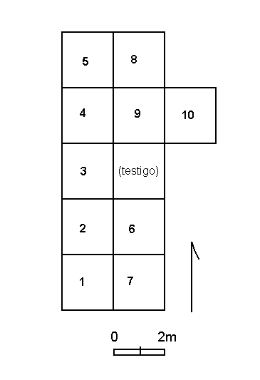

Figura 4: El Porvenir, Mound 1, Schematic Plan of Excavation Units
Floor 4: A layer of brownish grey (10 YR 6/2) to brown (10 YR 4/3) clay 5-10 cm thick was encountered in Units 3, 6, 9 and 10. Patterns of paired postmolds indicate the presence of an elliptical structure estimated to be 8 X 6 m in area. The well-preserved floor shows no evidence of erosion, suggesting that the structure was roofed; a layer of light grey fine ash on the floor probably derives from the burned thatching. An oval basin hearth (90 x 50 cm) made from mud and large shells was found in Unit 6; it is possible that the hearth was originally partially enclosed. Another trait was the presence of circular “adobes,” hand molded discs some 28 cm in diameter and 6.5 cm thick that were visible in the floor. These adobes were 50 cm apart and do not represent a wall; they may have been post supports or possibly a decorative detail intentionally incorporated into the floor. Floor 4 has Garbanzal White on Red plates associated with the structure.
Floor 5: A level associated with compact clay floor ranging in color from brown (10 YR 4/3) and grey (10 YR 5/1) and associated paired post-molds. Much of Floor 5 was destroyed during the construction and occupation of Floor 4, but a sufficient portion of the floor remains visible in plan and profile to tentatively reconstruct an elliptical structure 5-6 meters long and 3-4 meters wide.

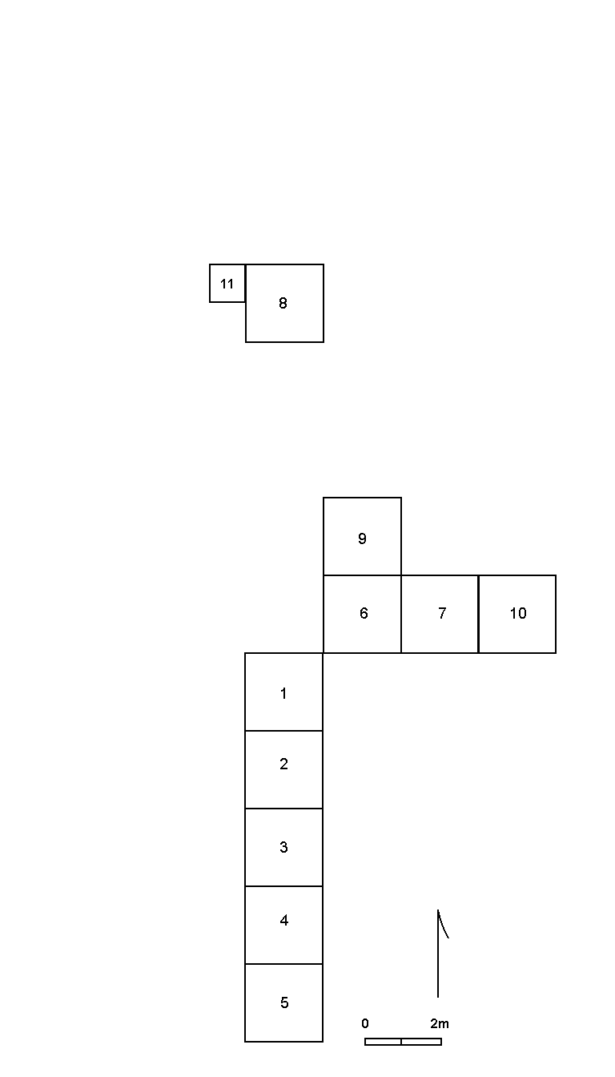
Figura 4: El Porvenir Mound 2, Schematic Plan of Excavation Units

Floor 6: This level consists of a floor consisting of compacted brown (10 YR 5/3) midden and a curving wall of paired postmolds. The postmold patterns suggest a structure that is 5 m in diameter. Initial examination of associated ceramics suggested that the level dated to the Late Formative; subsequent radiocarbon dating indicates a Late Archaic/ Early Formative occupation.
Floor 7: The level consists of a small fragment of well-made light brownish grey (10 YR 6/2) floor found in the northern portion of Unit 6, Level 6. No other architectural or archaeological features were associated with this floor, and its relative position to the other floors in Mound I is not established.

El Porvenir-Mound II
The excavations at Mound II began on May 30 and continued until June 27, 2006, when they were suspended until July 18 – 31, 2006 when limited excavations resumed during the final days of the field season. The initial block of excavations was a line of five 2 X 2 m test pits (Units 1-5) arrayed on the north-south axis of the mound and a perpendicular line of three 2 X 2 m pits running east-west (Units 6, 7 and 10). Additional test pits (9, 12, and 13) were excavated to follow architectural features initially encountered in the original test pits. An isolated 2 X 2 m pit, Unit 8, was excavated on the northern slope of the mound to test and area of particularly dense midden. An adjacent 1 X 1 m test pit, Unit 11, was excavated on the northwest corner of Unit 8; the midden from Unit 11 was water-screened through 3 mm mesh to recover a larger sample of fish bones and other small materials.
These excavations identified three prehispanic floors:
Floor 1: This is a compact level of various colored clay with small sections of plastered mud floor, ranging in colors from light yellow (2.5 Y 8/2) to olive-brown (2.5 Y 4/3), and found in Units 1, 2, 3, 6, 7, 9 and 10. The floor was associated with a rectangular structure estimated to be 9.2 X 4.25 m in area. A large number of clay daub fragments with cane impressions indicate that the building was a wattle and cane construction. The in situ fragments of a Garbanzal vessel in Units 2 and 3 provide a relative date for Floor 1, although the absolute dates were somewhat surprising. Although Floor 1 was extremely clean and most of its midden apparently was dumped on the north side of the mound, small fragments of shell and bone, obsidian flakes, sherds of utilitarian ceramics, and small fragment of a modeled anthropomorphic figurine suggest that Floor 1 was a domestic structure.
Floor 2: Floor 2 was encountered in Units 1, 3, 4, 12 and 13. This level is marked by a thick floor of plastered grey (10 YR 6/1) clay, areas of yellowish-brown (10 YR 5/4) clay floor and sets of postmolds indicating an elliptical structure approximately 7 m X 3-4 m in size. While most of the postmolds are paired and indicate a curvilinear wall, several larger post molds are interpreted as upright posts possibly supporting ridge-beams. The construction methods associated with Floor 2 are similar to those used in Mound I Floors 4 and 5.
Floor 3: This floor is largely destroyed by subsequent construction and is limited to a section of gray (10 YR 6/1) clay floor, a pair of post molds and an oval basin hearth located in Units 1 and 7. Since little of this floor remains, it was impossible to reconstruct the size or form of the structure, however it was evidently similar to Mound I, Floor 4, in the use of a thick grey clay floor and an oval basin hearth. The hearth was made from clay slathered onto shell valves and has an overall area of 120 X 60 cm with a central depression of approximately 40 X 40 cm filled with ash.

Loma Saavedra: Operation 1
Excavations at Loma Saavedra began on June 29 and ended on July 27, 2006. The excavations initially were laid out as an 8 X 10 m block of twenty 2 X 2 m units. Another seven units were excavated either to follow architectural features exposed in adjacent units or further expose in situ ceramic vessels. Although the excavations were relatively shallow, four distinct floors were exposed in the excavations (Figure 5, 6).

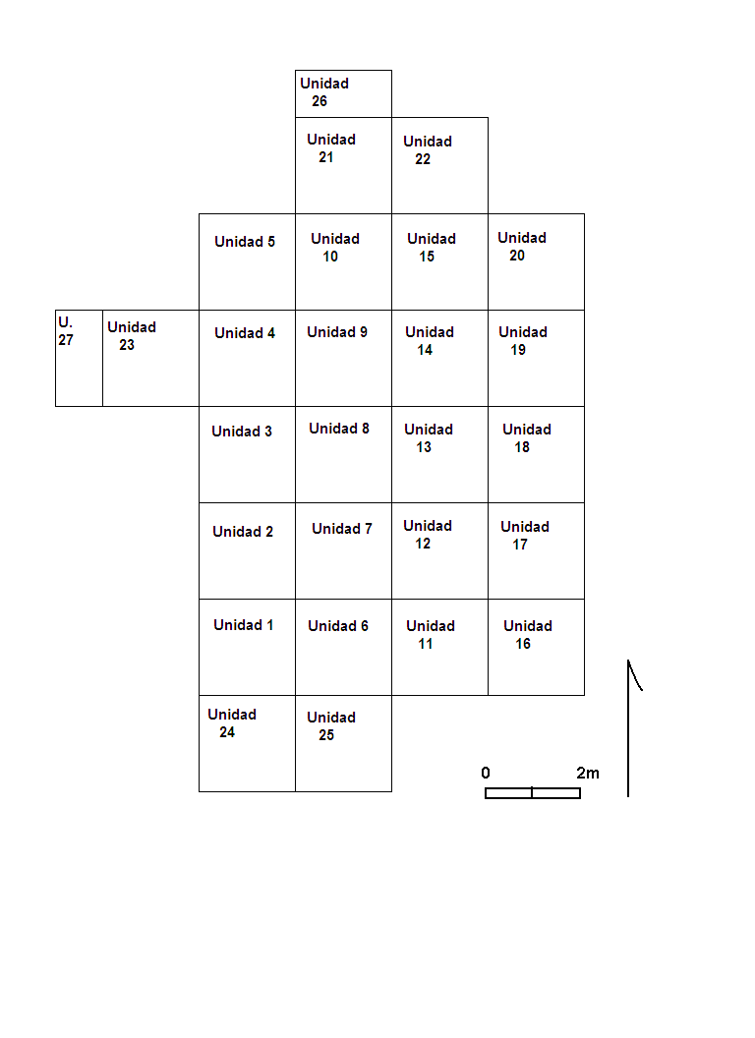

Figura 5: Loma Saavedra, Operation 1, Schematic Plan of Excavation Units.

Floors 1 and 2 exhibit “remodeling” episodes in which new layers of mud were plastered over earlier floors. Floor 1 was actually replastered twice, with each layer capping a clean layer of sand at least 1 cm thick, yet only to the extent of the original floor. This suggests that the limits of Floor 1 represent the extent of an enclosed, probably walled area. Floor 1 appears to be a rectangular structure 4.15 X 3.9 m in area. Similarly, Floor 2 was replastered at least once. Floor 2 was incompletely exposed, but based on its southwestern corner, seems to be a rectangular structure more than 5 X 5 m in area.
Floor 3 was extensively disturbed by the roots of a nearby ceiba tree, but was at least 4.5 X 4 m in area.
The greatest concentration of postmolds is associated with Floor 4, the earliest floor in Operation 1. Some of the postmolds appear to represent a structure although the overall plan of the structure could not be determined. It is likely that this house was built using a wattle and daub technique known as tabique, a construction method in which the wattle consists of sticks jammed between horizontal beams attached to vertical uprights. Other smaller postholes probably represent various non-architectural features.

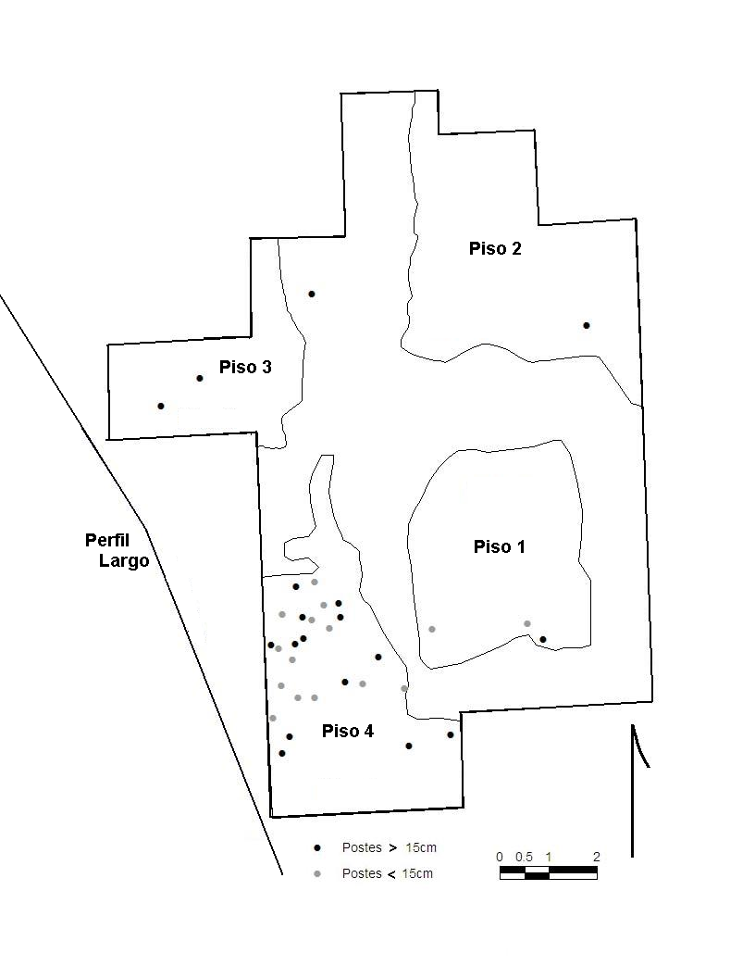

Figure 6: Loma Saavedra, Operation 1, Excavated Floors (Pisos)

2) Major Findings
The 2006 fieldwork resulted in major archaeological findings relevant to four research domains: 1) chronology, 2) domestic architecture and the uses of social space, 3) ceramic forms and stylistic changes, and 4) subsistence and exchange.

Chronology
A basic hurdle in understanding the prehistory of far northern Peru is the absence of a refined chronology based on absolute dating. Until recently the chronological framework for Tumbes was derived from the 1960 excavations at Pechiche and Garbanzal (Izumi and Terada 1966) and cross-referenced with work in southern Ecuador by Estrada, Meggers and Evans (1964). In essence this was a broad tripartite scheme of Formative (1800? – 500 BC), Regional Development (500 BC – AD 500/800) and Integration (AD 800- 1500) periods. In turn these periods were associated with specific ceramic complexes, with the San Juan style marking the Formative, Garbanzal ceramics—especially White on Red styles—marking the Regional Development period, and then a suite of intrusive styles (paddle-stabbed, press-molded black burnished wares, and polychrome ceramics) thought to be associated with intrusive cultures from the south—Lambayeque, Chimú and Inca.

Adjusted for
Sample Provenience RCYBP Reservoir Effect Calibrated Associated Ceramics
(2 sigmas)
182750 Perf. Largo Level 3/26cm 830+60 550+120 AD 1505-1910
182751 Op.1 Level 4/16cm 920+60 640+120 AD 1450 – 1910 Chimú-Asa Estribo
182752 Op. 1 Level 11/38cm 1100+60 820+120 AD 1315 – 1695 Jambelí Punteado
182753 Op. 2 Level 7/110cm 990+60 710+120 AD 1415-1885 piso intacto
182754 Op. 3 Level 3/40cm 1200+60 920+120 AD 1260-1645 Garbanzal Blanco Sobre
Rojo; Jambelí Punteado
182755 Op. 3 Level 5/70 cm. 1350+60 1070+120 AD 1070-1480 Garbanzal Blanco Sobre
Rojo; Jambelí Punteado
182757 Op. 3 Level 7-8/105cm 1270+70 990+120 AD 1190-1535 Compotera de pasta tosca
182758 Op. 3 Level 8/107cm 1350+60 1070+120 AD 1070-1480 Jambelí Rojo Pulido
182760 Perf. Este @140 cm. 1180+70 900+120 DC1275-1660 Garbanzal Tosco
182759 Perf. Este @240 cm. 1380+60 1100+120 DC1050-1460 Garbanzal Tosco
222685 Op. 1 Unidad 19 Level 4 430 + 50 -- AD 1420 – 1520 y Chimú, Chimú-Inca, Inca,
AD 1580 -1630
Table 1: ¹⁴C dates from Loma Saavedra and associated ceramic styles.
(Sample 222685 was collected during the 2006 fieldwork, other samples during the 2003 field season.)

Since 2003 and more recently, we have learned that not only is this schema vague, but it is incorrect in fundamental ways. The following is a partial list of major findings relating to chronology.
- The prehistoric record in Tumbes is several millennia older than previously thought and earlier than Formative developments in adjacent regions of South America. El Porvenir, Mound 1, Floor 6 is older than 4710-4220 BC (calibrated at two sigmas). This architectural feature appears to be a substantial permanent structure, one of the characteristics of the Formative Period, and suggesting the Formative occurred during the 5th millennium BC in the Department of Tumbes. In addition, this suggests the Formative developments occurred somewhat earlier in Tumbes than in the southern Ecuadorian highlands, where it is dated to ca. 2000 BC (Guffroy 2004) or in southwestern Ecuador, where the Early Valdivia is thought to begin at ca 3500 BC (Raymond 2003; Zeidler 2003).
- The Late Formative occupations for El Porvenir are cross-dated by distinctive ceramic styles found in adjacent regions of southern Ecuador. A small number of ceramics from El Porvenir contain incised motifs identical to those discussed by Guffroy (2004) for his Catamayo C (ca. 900 – 500 BC) and Catamayo D (500 – 300 BC) for Loja in the southern Ecuadorian highlands. Interestingly, the ceramic assemblages are otherwise not identical, but these have a small percentage of stylistic motifs in common, suggesting some form of interaction or exchange rather the complete equivalency of Late Formative ceramics in the two regions.

BETA Unit Level RCYBP Ajusted for Calibrated
Reservoir Effect (@ sigmas)
222663 Mound 2 8 3 2920+70 2640+120 BC 750 – 70
222664 Mound 2 8 3 2610+50 ---- BC 830 -770
222665 Mound 2 8 102 cm 2790 + 50 BC 1130 - 880
222666 Mound 2 7 3 2620 +60 BC 910 -780
222667 Mound 2 8 38 cm 2830 + 70 2430 + 70 BC 790 - 400
222668 Mound 2 8 51 cm 3090 +70 2690+70 BC 1090 - 780
222669 Mound 2 8 68 cm 2800 + 80 2400+ 70 BC 790 - 370
222670 Mound 2 8 96 cm 3080+70 2700+60 BC 1070 -780
222671 Mound 2 8 102 cm 6160 + 60 5800+60 BC 4770 - 4490
222672 Mound 2 5 6 3050 + 50 BC 1420 - 1190
222673 Mound 2 6 2 5320+60 4960+50 BC 3890 -3620
222674 Mound 1 3 7 2680+50 BC 920-790
222675 Mound 1 6 4 2680+50 BC 940-800
222676 Mound 1 6 5 2660+50 BC 920-790
222677 Mound 1 1 7 2920+50 BC 1280-970
222678 Mound 1 10 5 3130+70 2720+70 BC 1150 - 800
222679 Mound 1 6 6 3790+90 3400+70 BC 1970 -1580
222680 Plaza 2 1 3 3960+60 3560+50 BC 2160-1860
222681 Plaza 2 1 4 5830+50 5450+50 BC 4370-4220
222682 Mound 1 8 5 3380+70 2970+70 BC 1440 - 1110
222683 Mound 1 8/5 6 6260+70 5890+60 BC 4710-4220
222684 Mound 2 1 4 6270+90 5910+80 BC 4770-4200

Table 2: ¹⁴C dates from El Porvenir. (Collected during 2006 field season. Shell samples adjusted for reservoir effect.)

- Garbanzal White on Red ceramics are not exclusively associated with the Regional Development Period, but also date to the Late Formative (ca. 1000 – 300 BC) periods. While Izumi and Terada (1966) had defined another white on red style as Pechiche and associated it with the Middle Formative, the Garbanzal ceramics were thought to date to the later, Regional Development Period. Although Garbanzal styles may have been used into the Regional Development Period, there are clear examples from El Porvenir that date to BC 1200 – 700 yet are identical to Garbanzal forms (see “Ceramics” below).
- Another form of white painted ceramic—Late Jambelí White on Brown—is securely dated to AD 1420 – 1520 based on dates obtained during 2003 and corroborated in 2006. This ceramic style is found in association with Chimú and Chimú-Inca ceramics.

Domestic Architecture and the Use of Social Space
The excavations at El Porvenir and Loma Saavedra documented diachronic shifts in domestic architecture and the use of space. Although the data from these two sites appear to bracket the chronological endpoints of Tumbes’ prehistory, the architectural patterns document significant transformations in the form, construction methods, and size of prehistoric domestic architecture. The major findings include:
- As noted above, the earliest architectural remains from El Porvenir date to before 4710 – 4220 BC. This early construction is significantly more substantial than the contemporary Las Vegas culture house discussed by Stothert (1988) or the later Early Valdivia houses described by Damp (1988).
- There are important changes through time in house form, with Early – Middle Formative constructions being circular or elliptical in plan with rectangular structures developing in the Late Formative and thereafter, including at Loma Saavedra. The shift from circular to rectangular dwellings has been discussed extensively by Flannery (1972, 2002), who hypothesizes that this shift—which occurs in different regions of the world—was associated with changes in other social dimensions, including the reorganization of the domestic group, the privatization of storage, the increased importance of agriculture, and reordering of marriage practices. It is noteworthy that this change in house form is also known from Currie’s (1989) excavations at the site of Guarumal, Province of El Oro, Ecuador, but from later contexts; Currie suggests this shift occurred at AD 50 –100, but the El Porvenir data point to a much earlier date for this transformation in Tumbes, by circa BC 850 –700.
- There are significant changes in building techniques through time, as follows:
  - Archaic/Early Formative: circular pole and thatch structures without prepared floors;
  - Middle – Late Formative: elliptical pole and thatch structures with thick grey clay plastered floors;
  - Late Formative-Early Regional Development Period: rectangular, cane-wattle and daub houses with compact floors; and,
  - Integration Period: rectangular structures, possibly built using tabique techniques, with clay plastered floors that are periodically remodeled/reapplied.
- While there were shifts in the form and construction methods of domestic architecture, there was a striking continuity in settlement plan. A noteable feature at both El Porvenir and Loma Saavedra is the degree to which subsequent constructions are anchored to specific building areas. This is clearly the case at El Porvenir where multiple constructions in Mounds I and II pivot around spatial loci over centuries. There is no obvious reason why this should occur: alternative building space was available, there are no topographic advantages (e.g., better drainage) for building in one space or another, and constructions were not constrained by dense packing of buildings as in densely occupied urban settlements. At El Porvenir, the settlement seems to have consisted of a set of housemounds surrounding an open plaza from 1300 – 400 BC. This plan parallels the spatial organization of Early and Middle Valdivia communities (Zeidler 1984) and various ethnographic settlements known from lowland South America. At the site of Real Alto, for example, Zeidler (1984:54) has commented on the “intentional maintenance of the settlement pattern,” and this was equally true at El Porvenir. The intensive use of specific nodes of social space is indicated by the placement of an offering of beads, a whole Spondylus shell and a large gastropod shell in the middle of a fill deposit in Mound II, Unit 1, Level 3; this fill layer is estimated at 100 – 168 m3 that was placed immediately before the construction of Floor 1. Again, there is no “pragmatic” reason for such activities, yet they indicate the symbolic significance of this use of space.

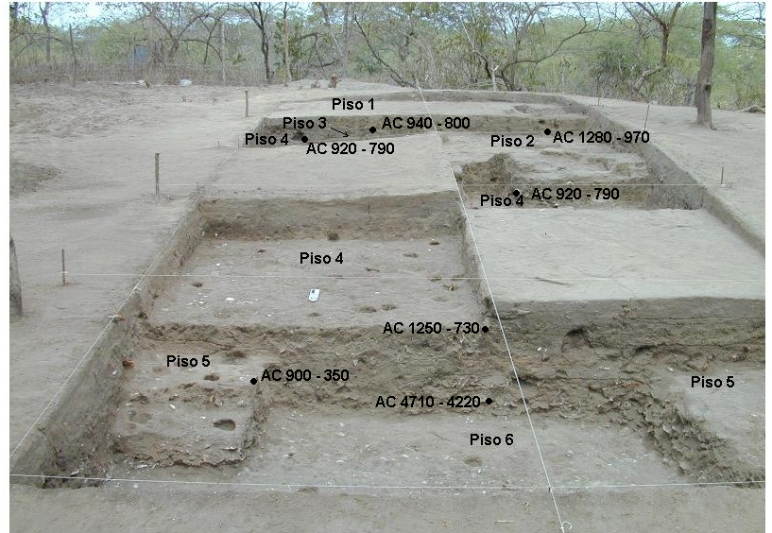

Figure 7: El Porvenir, Mound 1, Superimposed Floors (Pisos) and Associated ¹⁴C Dates (AC = BC)

Ceramics
The ceramic analysis is at a very preliminary stage, but a few initial comparative observations include.
- Ceramic forms from El Porvenir include a number of plate forms identified at the site of Garbanzal, but do not include pedestal bowl (compotera) that are one of the key traits of Garbanzal ceramic complex as initially defined. The upper levels at El Porvenir contain ceramics virtually identical to that initially defined at Garbanzal and Pechiche (Izumi and Terada 1966) including 8 of the 21 the plate forms and identical white on red surface treatments. However, the pedestal bowl (compotera) form was not found at El Porvenir. Again, since these ceramics are derived from Late Formative deposits at El Porvenir, a reassessment of the ceramic chronology is clearly required.
- Deep plate forms from El Porvenir appear similar to forms described for the Late Formative of southern Ecuador. These Ecuadorian forms are referred to as Early Engoroy by Bischof (1982) and Chorrera by Beckwith (1996).
- Ceramics from Loma Saavedra are principally coil-made vessels that appear more similar to local assemblages rather than similar to Milagro-Quevedo ceramics of Ecuador. The forms from Loma Saavedra are similar to those present in the ceramic assemblage salvaged from the site of La Palma, located 6 km upriver from Loma Saavedra (Pajuelo 2006).

Figura 8: El Porvenir, Relative Percentage of Vessel Forms

- Although 98% of the Loma Saavedra assemblage is coil-made pottery of local styles, a small but consistent quantity of press-molded blackware ceramics of either Chimú or Chimú-Inca manufacture are present in the assemblage. These are identified by pelican, monkey and other zoomorphic motifs.

Figura 9: Loma Saavedra, Vessel Forms

- There is a difference in the relative proportion of vessel forms at El Porvenir and Loma Saavedra. Given the preliminary nature of these data, it is difficult to interpret the significance of the differences in the assemblages. The higher proportion of plates at El Porvenir vs. Loma Saavedra may reflect differences in feasting activities, while the presence of tinajas at Loma Saavedra may reflect brewing of maize chicha at that late prehispanic site.

Subsistence and Exchange
The excavations at El Porvenir and Loma Saavedra recovered significant quantities of data relating to patterns of resource use and exchange. The data on resource use related principally to fauna—mollusks, fish and terrestrial fauna—while the data on exchange was limited to obsidian, but with interesting result. In sum the major findings are:
- There is a basic continuity in the habitats exploited for shellfish collection, although there were significant shifts in molluscan species in the assemblages. Essentially, prehispanic collectors exploited the mangroves, estuaries and lagoons, and to a lesser extent the open beaches of the Tumbes/Jambelí coastlines. This is true in the Early – Late Formative/Regional Development deposits at El Porvenir and the Integration Period deposits at Loma Saavedra. Yet, there were significant changes in the species exploited that probably reflect major environmental fluctuations rather than changes in collection strategies. This is most obvious in the data from El Porvenir, Mound II, Unit 8. In the lower strata, Ostrea sp. is the major molluscan species, comprising as much as 97% by weight in Level 5, which dates to ca 4770 – 4490 BC. In contrast by 790 –400 BC, oyster makes up only 23% of the assemblage by weight while Protothaca thaca—which never makes up more than 5% of the lower strata—becomes the dominant species at 53%. The disappearance of oyster also occurred in El Oro, as noted by Staller (1994:168-169) who observes that oyster was extensively used in Early Formative sites but disappears at Middle Formative and Late Formative deposits before reappearing during the Regional Development Period. This strongly suggests a major environmental event that adversely impacted oyster beds rather than a shift in resource preference or over-exploitation.
- Variation in fish species indicate that inhabitants of El Porvenir and of Loma Saavedra indirectly had access to species taken by fishing specialists exploiting mangroves, lagoons, and open ocean habitats. At El Porvenir the vast majority 60% of the identified fish remains are from Cupleiforms (anchovy and herrings) and various types of marine catfish (Family Arridae). At Loma Saavedra, mullet (Mugil sp), which is found in muddy bottom habitats from rivers out to the continental shelf, is the most numerous species present, although there are also small quantities of bonito and tuna that are only found in open ocean associated with reefs and must be fished from boats with hook and line; bonito and tuna were not recovered from El Porvenir. However, at both sites the mix of species present suggests the extensive use of fish weirs probably built in shallow water lagoons. Fishing weirs, ocean-going watercraft, and other specialized equipment probably points to the existence of coastal fishing communities who exchanged their catch for resources available to the inland communities of El Porvenir and Loma Saavedra.
- Significant differences in terrestrial faunal assemblages point indicate a late prehistoric political economic strategy implemented by the Chimú or the Inca empires. The late prehispanic site of Loma Saavedra has a suite of Andean domesticated fauna that are absent in the earlier site of El Porvenir. Loma Saavedra has abundant evidence of llama (Lama glama), other camelids (Llama sp.) and guinea pig (Cavia cf. porcellus) that are absent in the deposits at El Porvenir. Large mammals were more abundant at Loma Saavedra and included not only the Andean domesticates, but dog and white-tailed deer (Odocoileuos virginanus) and other artiodactyls. Virginia deer and artiodactyls are present in the assemblage at El Porvenir, although they are relatively minor compared to marine resources. The difference in these faunal assemblages may reflect the role of the Inca or possibly the Chimú empires in introducing exotic fauna as part of a political strategy. According to ethnohistoric sources, Tumbes was developed by the Inca into a provincial buffer between Tawantinsuyu and the rebellious and war-like chiefdoms of Isla Puná (Murra 1946:809). Early Spanish descriptions of Tumbes comment on the numerous llamas and guinea pigs in the valley (Ruiz del Arce 1968 [1545]: 419). It is hypothesized that the abundant presence of llama and guinea pig in the Tumbes region will date to the late prehispanic period.
- Limited but clear-cut evidence indicates the presence of obsidian exchange networks connecting Tumbes to northern and southern Ecuador by circa BC 1200 – 700. A small number of obsidian flakes (n=5) were found at El Porvenir, Mound II, that have been identified as from two Ecuadorian sources: Mullumica, located east of Quito in the Cordillera Real of northern Ecuador (Burger et al.1994) and Carboncillo, in the southern Ecuadorian highland province of Loja, recently identified by Dennis Ogburn (personal communication). Mullumica is approximately 435 km from El Porvenir, while Carboncillo is 115 km distant. Obviously, this is a very small data set, but it does suggest that some form of long-distance exchange networks existed by the Late Formative that were sufficiently extensive to include—if only in a limited way—small prehispanic communities like El Porvenir.

3) References Cited/Selected BibliographY
Beckwith, Laurie
1996 Late Formative Ceramics from Southwestern Ecuador. Unpublished Ph.D. dissertation, University of Calgary, Canada. UMI Microfilms.
Burger, Richard
1984 Archaeological areas and prehistoric frontiers: the case of Formative Peru and Ecuador. In Social and Economic Organization in the Prehispanic Andes, edited by D. Browman, R. Burger and M. Rivero, pp. 33-71. British Archaeological Research International Series, 194. BAR Oxford.
Burger, Richard, Frank Asaro, Helen Michel, Fred Stross, y Ernesto Salazar
1994 An Initial Consideration of Obsidian Procurement and Exchange in Prehispanic Ecuador. Latin American Antiquity 5 (3): 228-255.
Coker, Roberto
1910 La Ostra en Tumbes con Observaciones sobre las condiciones físicas y la historia natural de la región. Boletín de la Dirección de Fomento, tomo 8, paginas 64-115. Lima: Oficina “La Opinión Nacional.”
Currie, Elisabeth
1985 La cultural Jambelí con referencia particular al conchero Guarumal. Memoria del Primer Simposio Europeo Sobre Antropología del Ecuador, edited by Segundo Moreno Yanez, pp. 31-46. Ediciones Abya Yala, Quito.
1989 Cultural Relationships in Southern Ecuador 300 BC – AD 300: Excavations in the Guarumal and Punta Brava Sites, PhD dissertation, Institute of Archaeology, University College, London.
Damp, Jonathan
1984 Architecture of the Early Valdivia Village. American Antiquity 49:573-585.
Estrada, Emilio, Betty Meggers and Clifford Evans
1964 The Jambelí culture of south coastal Ecuador. Proceedings of the United States National Museum, vol. 115. pp. 483-558. Smithsonian Institution, Washington D.C.
Fischer, W., F. Krupp, W. Schneider, C. Sommer, K.E. Carpenter, and V.H. Niem.
1995a. Guia FAO para la Identificacion de Especies para los Fines de la Pesca: Pacifico Centro-Oriental, Vol. II, Vertebrados - Parte I. Organizacion de las Naciones Unidas para la Agricultura y la Alimentacion, Roma.
1995b. Guia FAO para la Identificacion de Especies para los Fines de la Pesca: Pacifico Centro-Oriental, Vol. III, Vertebrados - Parte II. Organizacion de las Naciones Unidas para la Agricultura y la Alimentacion, Roma.
Flannery, Kent
1972 The Origins of the Village as a Settlement Type in Mesoamerica and the Near East: A Comparative Study. In Man, Settlement, and Urbanism, editado por R. J. Ucko, R. Tringham y G.W. Dimbleby, páginas 23- 53. Duckworth, London
2002 The Origins of the Village Revisited: From Nuclear to Extended Households. American Antiquity 67 (3):417-433.

Guffroy, Jean; Peter Kaulicke y Krysztof Makowski,
1989 La Prehistoria del Departamento de Piura: Estado de los Conocimientos y Problemática. Bulletin de L’Institut Franais d’Etudes Andines. 22 (3):701-719. Lima. IFEA.
Guffroy, Jean
2004 Catamayo Precolombino: Investigaciones arqueológicas en la provincia de Loja, Ecuador. IRD Edition, Paris.
Hill, Betsy D.
1975 A new chronology of the Valdivia ceramic complex from the coastal zone of Guayas Province, Ecuador. Ñawpa Pacha 10-12:1-32
Hocquenhem, Ann Marie,
1991 Frontera entre “Areas Culturales” Nor Andinas y Centroandinas en los Valles y en la Costa del Extremo Norte Peruano. Bulletin del Institut Francais d’Etudes Andines, 20(2): 309-348.
1993 Rutas de Intercambio del Mullu. Bulletin del ‘Institut Francais d’Etudes Andines, 22(3): 701 – 719.
1994 Intercambios entre los Andes Centrales y Norteños en el Extremo Norte del Perú, en: 1º Reunión de Investigadores de la Costa Ecuatoriana en Europa. Museu etnologic. Barcelona 9 - 11 de Junio de 1993. Barcelona
1994.“Los Españoles en los Caminos del Extremo Norte del Perú en 1532”. En: Bulletin de L’Institut Francais d’Etudes Andines. 23(1): 1-67, Lima. IFEA.
1998 Para Vencer la Muerte: Piura y Tumbes—Raices en el Bosque Seco y en la Selva Alta—Horizontes en el Pacífico y en la Amazonia. Travaux de l’Institut Français d’Études Andines, tomo 109,
2004.“Una edad del bronce en los Andes Centrales: Contribución a la elaboración de una historia ambiental” (mimeo)
Hocquenhem, Ann Marie y Luc Ortlieb
1992 Eventos El Niño y lluvias anormales en la Costa del Perú.. Bulletin del Institut Francais d’Etudes Andines, 21(1):197-278.
Hocquenhem, Ann Marie, Jaime Idrovo, Peter Kaulick y D. Gomis
1993 “Bases de Intercambio entre Sociedades Norperuanas y Surecuatorianas: una Zona de Transición entre 1500 A.C. y 600 D.C.”. Bulletin de L’Institut Francais d’Etudes Andines. 22(2): 443 - 466. Lima. IFEA.
Hocquenhem, Ann Marie y Manuel Peña Ruiz
1994. La Talla de Material Malacológico en el Extremo Norte del Perú.. Bulletin de L’Institut Francais d’Etudes Andines, 23(2): 209 -229. Lima. IFEA.
Holm, Olaf
1985 Arquitectura Precolombina en el Litoral. Museo del Banco Central del Ecuador, Guayaquil
Idrovo Urigüen, Jaime
1994 Santuarios y Conchales en la Provincia de El Oro: Aproximaciones Arqueológicas. Casa de la Cultura Ecuatoriana, Macala, Ecuador.
Ishida, Eichiro
1960 Andes: The report of the University of Tokyo Scientific Expeditions to the Andes in 1958, 527p., E. Ishida, director, Tokyo.

Izumi, Seichi.; Kasuo Terada
1961 Excavations in the Valley of Tumbes, Perú. The Journal of the Antropological Society of Nipon (Zinruigaku Zossi), 68 :196 - 204 Tokyo.
1966 Andes 3: Excavations at Pechiche and Garbanzal, Tumbes Valley, Perú 1960, 109 p., Tokyo.
Lathrap, Donald, Donald Collier y Helen Chandra
1975 Ancient Ecuador: Culture, Clay and Creativity, 3000 – 300 BC. Field Museum of Natural History, Chicago.
Marcos, Jorge
1978 The Ceremonial Precinct at Real Alto: Organization of Time and Space in Valdivia Society. Tesis de doctorado, Universidad de Illinois, Urbana-Champaign.
2003 A Reassessment of the Ecuadorian Formative. In The Archaeology of Formative Ecuadro, editado por J. Scott Raymond y Richard Burger, paginas 7 - 32. Dumbarton Oaks, Washington D.C.
Mejía Xesspe, Toribio,
1960. “Algunos Nuevos elementos de la Civilización Recuay - Pasto en el extremo norte del litoral peruano”. En Antiguo Perú, Espacio y Tiempo. Semana de la Arqueología Peruana, 4-9 de Noviembre 1959: 205 - 217. Ed. Juan Mejía Baca. Lima.
Moore, Jerry, Bernardino Olaya Olaya, and Wilson Puell Mendoza
1996 Investigaciones del Imperio Chimú en el valle de Tumbes, Perú. Informe Técnico al Instituto Nacional de Cultura, Perú.
1997 Investigaciones del Imperio Chimú en el valle de Tumbes, Perú, Revista del Museo de Arqueología, Antropología e Historia No 7 pp. 173-184.
Moore, Jerry, Carolina Maria Vilchez, Bernardino Olaya Olaya, Eva Pajuelo y Andrew Bryan
2005 Informe Técnico: 2003 Excavaciones en el sitio Loma Saavedra. Instituto Nacional de Cultura, Peru.
Nurnberg, David, Julio Estrada Ycaza y Olaf Holm
1982 Arquitectura Vernacular en el Litoral. Archivo Historico del Guayas, Banco Central del Ecuador, Guayaquil.
Olaya, Bernardino,
1993 Hachas Moneda en el Caserío de Cristales, Tumbes. En: Revista del Museo de Arqueología, 4: 105 - 110. Universidad Nacional de Tumbes
Olaya Olaya, Bernardino y Julio Rodriguez
2004 Proyecto Qhapaqñan. Informe presentado al Instituto Nacional de Cultura.
Pajuelo, Eva
2006 Reassessing the Frontier: Implications of New Research in Tumbes, Peru. Ms on file at the University of Illinois, Urbana-Champaign
Pajuelo, Eva y Jerry Moore
2005 Reclaiming the Frontier: Material Expressions and the Appropriation of the Past in Late Prehispanic Tumbes, Peru. Ponencia presentado the Institute for Andean Studies, Annual Meeting, January 7-8, 2005. Berkeley
Peña Ruiz, Manuel,
1993 Taller Malacológico de Cabeza de Vaca. Ponencia presentada al 1er Congreso Regional de Arqueología y Etnohistoria del Norte Peruano. Piura, Junio 14-18. 1993.
1994 El Taller de Conchas de Cabeza de Vaca. Ed. Hualtaco. 12 págs.
Petersen, George,
1962 Las primeras operaciones militares de Francisco Pizarro en el Perú. En Actas y Trabajos del II Congreso Nacional de Historia del Perú. Vol II: 359-383. Centro de Estudios Histórico - Militares del Perú. Lima
Puell Mendoza, Wilson,
1986. Tumbes: La Cultura Chimú y su desarrollo. en “LAVOR”, Tumbes. (Folleto)
1996 De la Naturaleza a las Ciencias Sociales, 57 p., Tumbes.
Puell, Wilson, Bernardino Olaya y Carolina Vilchez
1996 Reconocimiento y Evaluación de Sitios Arqueológicos en la Sub Región Tumbes, 1ra Parte., Informe presentado al Instituto Nacional de Cultura Tumbes.
Ravines, Rogger,
1973 Conchales del Río Zarumilla, Perú. Revista del Museo Nacional Tomo XXXIX. Lima.
Ravines, Rogger y Ramiro Matos
1985 Inventario de Monumentos Arqueológicos del Perú. Zona Norte. Primera Aproximación. Instituto Nacional de Cultura. Lima.
Raymond, J. Scott
2003 Social Formations in the Western Lowlands of Ecuador during the Early Formative. In The Archaeology of Formative Ecuadro, editado por J. Scott Raymond y Richard Burger, paginas 33-67. Dumbarton Oaks, Washington D.C.
Reitz, Elizabeth J. and Maria A. Masucci
2004 Guangala Fishers and Farmers: A Case Study of Animal Use at El Azúcar, Southwestern Ecuador. University of Pittsburgh Memoirs in Latin American Archaeology No. 14
Richardson, James D. III.,
1987 The chronology and affiliation of the Ceramic Periods of the Departaments of Piura and Tumbes, Northwest Perú. Paper presented at the 51 th Meeting of the Society for American Archaeology.
1992 The first encounter: Francisco Pizarro and The Inca site at Corrales, Perú. Paper presented at the Society for Historic Archaeology Meetings; Jamaica.
Richardson II, James, Mark McConaughy, Allison Heaps de Peña and Elenca Décima Zamecnik
1990 The northern frontier of the kingdom of Chimor: the Piura, Chira and Tumbez valleys. In The Northern Dynasties: Kingship and Statecraft in Chimor, edited by M. Moseley and A. Cordy-Collins, pp.419-445. Dumbarton Oaks Research Library and Collection, Washington D.C.
Schávelzon, Daniel
1981 Arqueología y arquitectura del Ecuador Prehispánico. Universidad Nacional Autónoma de México, D.F.
Siancas Machuca, Percy
1995 Inventario y Distribución Ecológica de Moluscos (Bivalvos y Gasterópodos en los Manglares de Puerto Pizarro, 1998-1989. Primer Encuentro por la Ecologia de Tumbes, 08 – 11 de Agosto 1995.
Staller, John
1994 Late Valdivia occupation in southern coastal El Oro Province, Ecuador: Excavations at the Early Formative Period (3500 – 1500 B.C.) site of La Emerencia. PhD dissertation, Department of Anthropology, Southern Methodist University.
2000 Political and prehistoric frontiers: how history influences our understanding of the past. In The Entangled Past: Integrating History and Archaeology, Proceedings of the 30th Annual Chacmool Archaeological Conference, edited by M. Boyd, J. Erwin and M. Hendrickson, pp. 242-257. Calgary, Alberta
2001 Reassessing the Developmental and Chronological Relationships of the Formative of Coastal Ecuador. Journal of World Prehistory 15 (2):193-256.
Stothert, Karen
1988 La Prehistoria Temprana de la península de Santa Elena: Cultura Las Vegas. Miscelánea Antropológica Ecuatoriana 10, Museo del Banco Central del Ecuador, Guayaquil.
Vilchez Carrasco, Carolina,
1996 Reconocimiento Arqueológico de Guineal. Quebrada Cusco-Valle de Tumbes. Informe presentado al CEPAT: Centro Eco Paleonto Arqueológico Tumbes.
1997 Estado Actual de los Sitios Arqueológicos del Departamento de Tumbes. Documento de Trabajo. Instituto Nacional de Cultura. Tumbes.
1998 Diagnóstico del Patrimonio Arqueológico del Parque Nacional Cerros de Amotape. Proyecto Inventario y Reconocimiento Arqueológico del Parque Nacional Cerros de Amotape. Jefatura PNCA-INRENA. Tumbes.
1999 Diseño Arquitectónico y Secuencia Constructiva de la Huaca Cabeza de Vaca. Valle de Tumbes. Proyecto de Investigación para Optar el Título de Licenciado en Arqueología. Universidad Nacional de Trujillo. Trujillo.
2002 Inventario Arqueológico de Tumbes. Dirección Regional de Cultura Tumbes. Tumbes.
2003 Camino Inca de la Costa – Tramo Tumbes. Proyecto Qhapaqñan del Instituto Nacional de Cultura. 80 págs. Tumbes.
2004 Proyecto Puesta en Valor del Monumento Arqueológico de Cabeza de Vaca - Corrales. INFORME FINAL. Dirección Regional de Cultura Tumbes, Proyecto Qhapaqñan del Instituto Nacional de Cultura, Programa A Trabajar Urbano. 131 págs. Tumbes.
Vilchez, Carolina, Jerry Moore y Eva Pajuelo, editors.
2007 Informe Final: Proyecto Arqueológico Tumbes, Excavaciones en El Porvenir y Loma Saavedra, Departamento de Tumbes. Technical Report submitted to Instituto Nacional de Cultura, Lima.
Zeidler, James
1984 Social Space in Valdivia Society: Community Patterning and Domestic Structure at Real Alto, 3000 – 2000 BC. PhD dissertation, University of Illinois, Urbana-Champaign.

